**Time :** 1Hour (3.30 PM to 4.30 PM) **Marks :** 30 Marks (M)

|  |  |  |  |
| --- | --- | --- | --- |
| ***Q.1*** | ***A)*** | Explain the different data models used in DBMS with the help of example. | ***5M*** |
|  | ***B)*** | What is meant by Mapping Cardinalities? Explain with diagrams | ***5M*** |
|  | ***C)*** | Design an E-R model for online book shop database system. List the entity set & their primary  Key. Extend the E-R Diagram using specialization. | ***5M*** |
|  |  | **OR** |  |
| ***Q.2*** | ***A)*** | What is data abstraction? Explain the various levels of data abstraction in database. | ***5M*** |
|  | ***B)*** | List the Advantage of a DBMS over file processing system. | ***5M*** |
|  | ***C)*** | Draw the ER diagram which model university Database. List the entity sets & their primary key. Extend the ER diagram using aggregation to model the case where we want to record evaluations of a student by a guide on a project. | ***5M*** |
|  |  |  |  |
| ***Q.3*** | ***A)*** | Consider Bank Relational Schema   |  |  | | --- | --- | | **Customer** **(** cust_name, cust_street, cust_city **)** | **Branch (** branch_name, branch_city, assets **)** | | **Account** **(** Acc_no, branch_name, balance **)** | **Depositor** **(** cust_name,acc_no **)** | | **Loan (** loan_no, branch_name, amount **)** | **Borrower** **(** cust_name,loan_no **)** |   Write the SQL queries for following requirements :   1. Write Create table query for all above tables. *( 6 Marks )* 2. Find the name and loan number of all customers having a loan at the   Lonavala branch. *( 2 Marks )*   1. Find all customers who have a loan at the bank but do not have an account   at the bank. *(2 Marks)* | ***10M*** |
|  | ***B)*** | Explain PL/SQL with the help of example. | ***5M*** |
|  |  | **OR** |  |
| ***Q.4*** | ***A)*** | Consider relational schema  **Employee** **(** Eno, Ename, Deptno, Salary **)**  **Department** **(** Deptno, Dname **)**  Write SQL Queries for following questions  ***i)*** List of employee names of 'Computer ' department.  ***ii)*** Find the Employee whose Salary above 50000 of each department.  ***iii)*** Find Department name of employee name 'Amit'. | ***5M*** |
|  | ***B)*** | Differentiate between SQL and PL/SQL | ***5M*** |
|  | ***C)*** | What is JOIN? Explain Different types of JOIN | ***5M*** |

***\*\*\*\*\*\*\*\*\*\*\*\*\*\*\*\*\*\*\*\*\*\*\*\* ALL THE BEST \*\*\*\*\*\*\*\*\*\*\*\*\*\*\*\*\*\*\*\*\*\*\*\*\*\*\*\*\*\*\*\*\*\*\*\*\*\*\****

### Q1.) Database Model

A Database model defines the logical design of data. The model describes the relationships between different parts of the data. Historically, in database design, three models are commonly used. They are,

* Hierarchical Model
* Network Model
* Relational Model
* Semantic Data Model

#### Hierarchical Model

In this model each entity has only one parent but can have several children . At the top of hierarchy there is only one entity which is called **Root**.

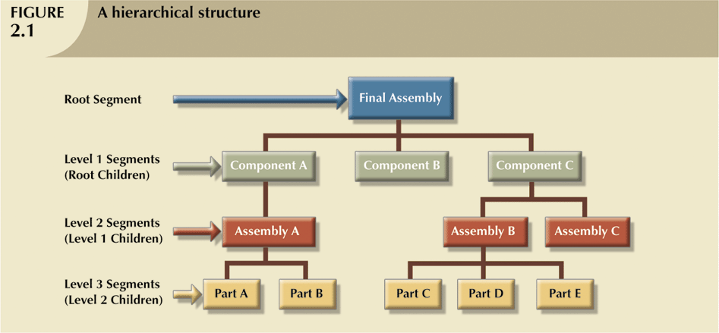

* The hierarchical structure contains levels, or segments
* Depicts a set of one-to-many (1:M) relationships between a parent and its children segments
  + Each parent can have many children
  + each child has only one parent

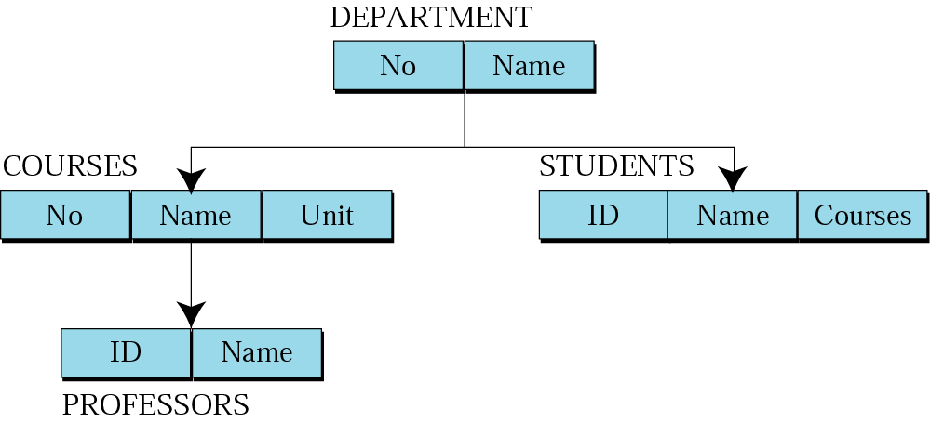

#### Network Model

In the network model, entities are organised in a graph,in which some entities can be accessed through several path .

* Created to
  + Represent complex data relationships more effectively
  + Improve database performance
  + Impose a database standard

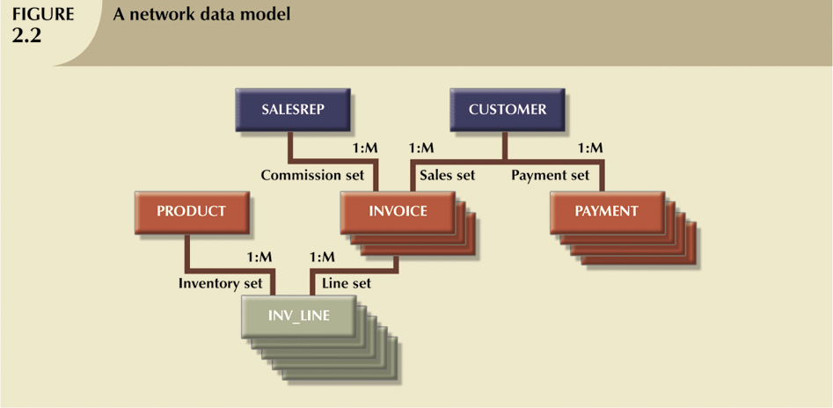

#### Relational Model

In this model, data is organised in two-dimesional tables called **relations**. The tables or relation are related to each other.

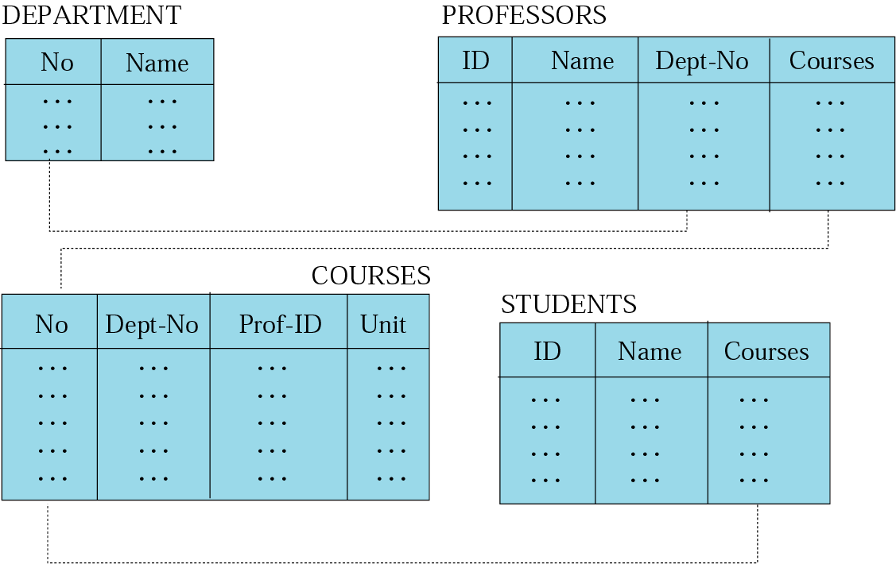

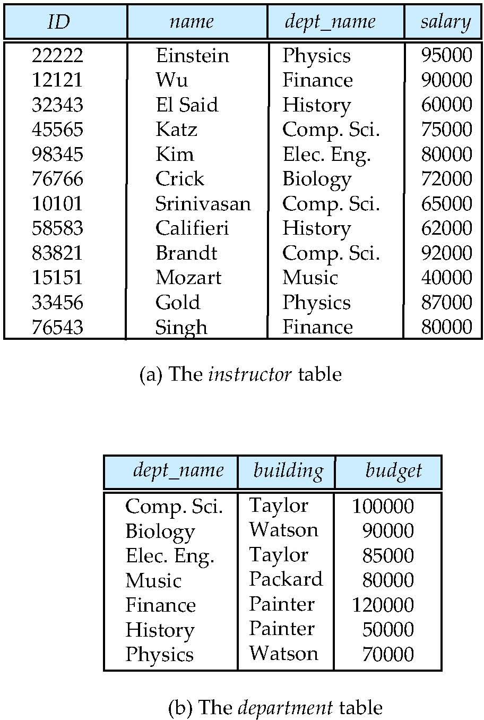

***The Entity Relationship Model:***

* ***Widely accepted and adapted graphical tool for data modeling***
* ***Introduced by Chen in 1976***
* ***Graphical representation of entities and their relationships in a database structure***
* ***Entity relationship diagram (ERD)***
  + ***Uses graphic representations to model database components***
  + ***Entity is mapped to a relational table***
* ***Entity instance (or occurrence) is row in table***
* ***Entity set is collection of like entities***
* ***Connectivity labels types of relationships***
  + ***Diamond connected to related entities through a relationship line***

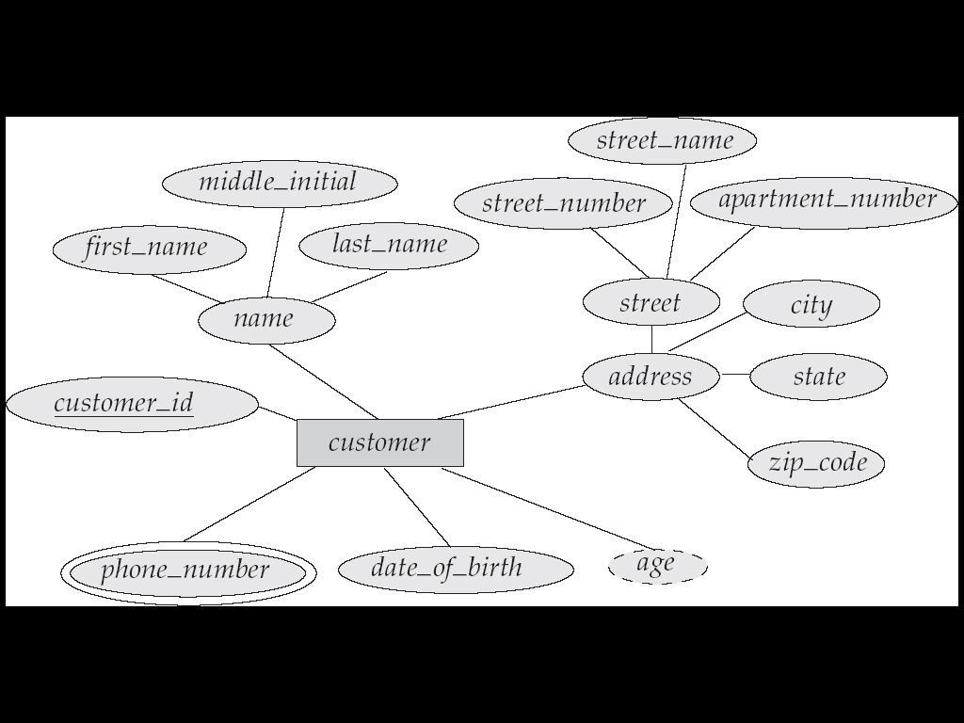

***B) What is meant by Mapping Cardinalities? Explain with diagrams.***

Mapping constraints can be explained in terms of [mapping cardinality](http://beginnersbook.com/2015/04/cardinality-in-dbms/):

**Mapping Cardinality**:  
**One to One**: An entity of entity-set A can be associated with at most one entity of entity-set B and an entity in entity-set B can be associated with at most one entity of entity-set A.

**One to Many**: An entity of entity-set A can be associated with any number of entities of entity-set B and an entity in entity-set B can be associated with at most one entity of entity-set A.

**Many to One**: An entity of entity-set A can be associated with at most one entity of entity-set B and an entity in entity-set B can be associated with any number of entities of entity-set A.

**Many to Many**: An entity of entity-set A can be associated with any number of entities of entity-set B and an entity in entity-set B can be associated with any number of entities of entity-set A.

• The appropriate mapping cardinality for a particular relationship set depends on the real world being modeled. (Think about the CustAcct relationship...)

• **Existence Dependencies:** if the existence of entity X depends on the existence of entity Y, then X is said to be **existence dependent** on Y. (Or we say that Y is the **dominant** entity and X is the **subordinate** entity.)

For example,

* Consider account and transaction entity sets, and a relationship log between them.
* This is one-to-many from account to transaction.
* If an account entity is deleted, its associated transaction entities must also be deleted.
* Thus account is dominant and transaction is subordinate.

***c)***Design an E-R model for online book shop database system. List the entity set & their primary

Key. Extend the E-R Diagram using specialization;

Problem : Consider the database of an online bookstore.

• Every book has a title, isbn, year and price. The store also keeps the author and publisher for any book.

• For authors, the database keeps the name, address and the url of their homepage.

For publishers, the database keeps the name, address, phone number and the url of their website.

• The store has several warehouses, each of which has a code, address and phone number.

• The warehouse stocks several books. A book may be stocked at multiple

warehouses. (In previous sentence, we are not referring to a particular copy of the book. Consider for example “the complete book” for our course. This book may be stocked at multiple warehouses.)

• The database records the number of copies of a book stocked at various

warehouses.

• The bookstore keeps the name, address, email-id, and phone number of its

customers.

• A customer owns several shopping basket. A shopping basket is identified by a basketID and contains several books.• Some shopping baskets may contain more than one copy of same book. The database records the number of copies of each book in any shopping basket.

Design an ER diagram for such a bookstore. You are NOT required to identify keys or constraints for this problem.

Answer

**STEP 1**

*Identify all the entities*

*-AUTHOR*

*-PUBLISHER*

*-BOOK*

*-CUSTOMER*

*-SHOPPING_BASKET*

*-WAREHOUSE*

**STEP 2**

*find the relations*

*1.Each book is written by a author*

*2.Each book has a publisher*

*3.* *Some shopping baskets may contain more than one copy of same book*

*4.* *The warehouse stocks several books*

*5.* *A customer owns several shopping basket*

**STEP 3**

*Identify the key attribute*

*\*AUTHOR- name*

*\*PUBLISHER- name*

*\*BOOK- ISBN*

*\*CUSTOMER- email*

*\*SHOPPING_BASKET- basket_ID*

*\*WAREHOUSE- code*

**STEP 4**

*Identify other relevant attributes*

*\*AUTHOR- name,address,URL*

*\*PUBLISHER- name,address,URL,phone*

*\*BOOK- ISBN,year,title,price*

*\*CUSTOMER- email, name,address,phone*

*\*SHOPPING_BASKET- basket_ID*

*\*WAREHOUSE- code, address,phone*

***1.Each book is written by author:*** 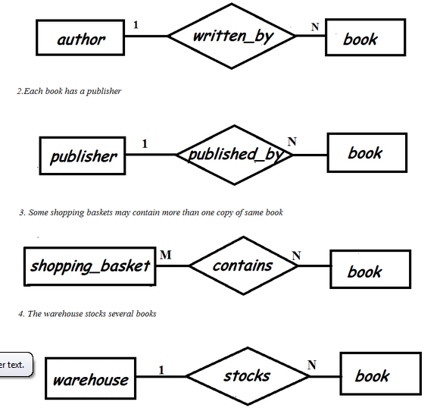

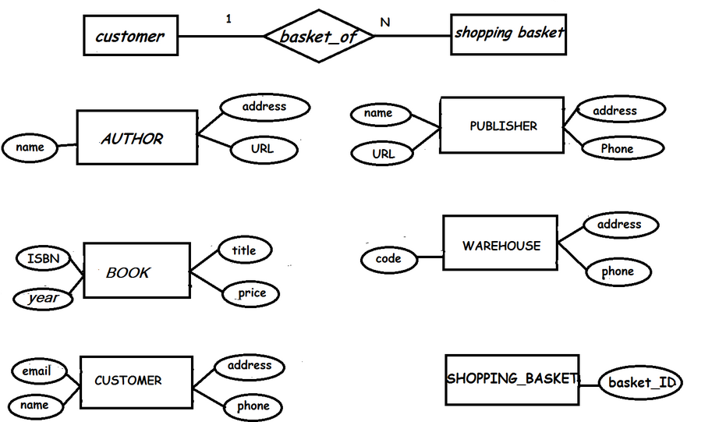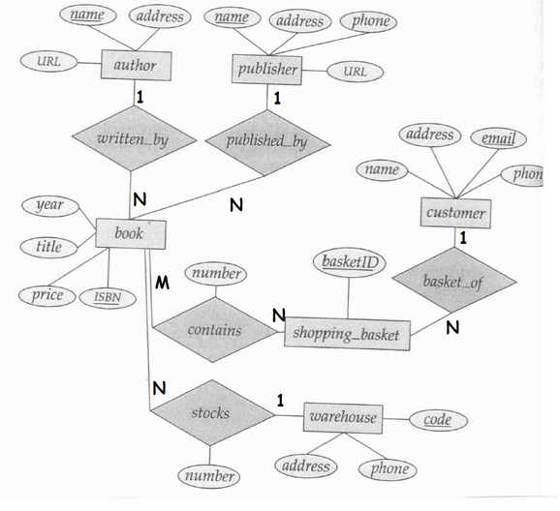

***OR***

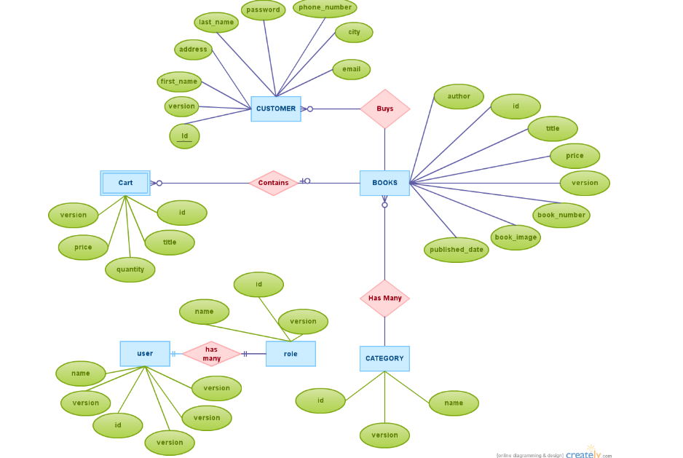

Q2.A) **What is data abstraction? Explain the various levels of data abstraction in database.**

Database systems are made-up of complex data structures. To ease the user interaction with database, the developers hide internal irrelevant details from users. This process of hiding irrelevant details from user is called data abstraction.

**We have three levels of abstraction**:  
**Physical level**: This is the lowest level of data abstraction. It describes how data is actually stored in database. You can get the complex data structure details at this level.

**Logical level**: This is the middle level of 3-level data abstraction architecture. It describes what data is stored in database.

**View level**: Highest level of data abstraction. This level describes the user interaction with database system.

**Example**: Let’s say we are storing customer information in a customer table. At **physical level** these records can be described as blocks of storage (bytes, gigabytes, terabytes etc.) in memory. These details are often hidden from the programmers.

At the **logical level** these records can be described as fields and attributes along with their data types, their relationship among each other can be logically implemented. The programmers generally work at this level because they are aware of such things about database systems.

At **view level**, user just interact with system with the help of GUI and enter the details at the screen, they are not aware of how the data is stored and what data is stored; such details are hidden from them.

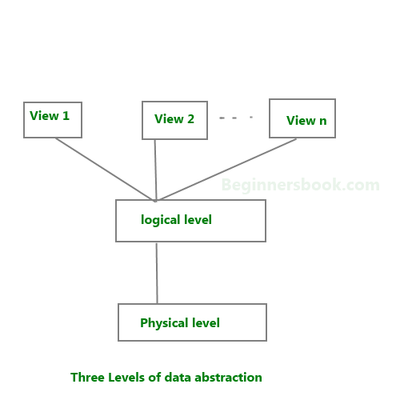

**Q2.B):=** List the Advantage of a DBMS over file processing system.

**Drawbacks of File system**:

* Data Isolation: Because data are scattered in various files, and files may be in different formats, writing new application programs to retrieve the appropriate data is difficult.
* Duplication of data – Redundant data
* Dependency on application programs – Changing files would lead to change in application programs.

## Advantage of DBMS over file system

There are several advantages of Database management system over file system. Few of them are as follows:

* No redundant data – Redundancy removed by data normalization
* Data Consistency and Integrity – data normalization takes care of it too
* Secure – Each user has a different set of access
* Privacy – Limited access
* Easy access to data
* Easy recovery
* Flexible

**Disadvantages of DBMS**:

* DBMS implementation cost is high compared to the file system
* Complexity: Database systems are complex to understand
* Performance: Database systems are generic, making them suitable for various applications. However this feature affect their performance for some applications

***Q2.C)*** Draw the ER diagram which model university Database. List the entity sets & their primary key. Extend the ER diagram using aggregation to model the case where we want to record evaluations of a student by a guide on a project.

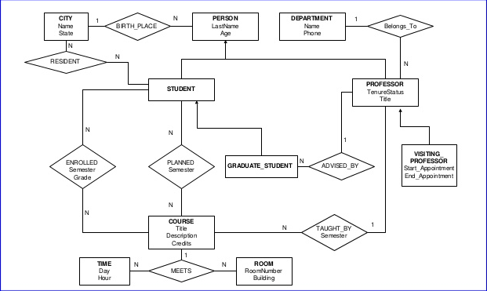

Q3.A)Consider Bank Relational Schema

|  |  |
| --- | --- |
| **Customer** **(** cust_name, cust_street, cust_city **)** | **Branch (** branch_name, branch_city, assets **)** |
| **Account** **(** Acc_no, branch_name, balance **)** | **Depositor** **(** cust_name,acc_no **)** |
| **Loan (** loan_no, branch_name, amount **)** | **Borrower** **(** cust_name,loan_no **)** |

Write the SQL queries for following requirements :

1. Write Create table query for all above tables. *( 6 Marks )*
2. Find the name and loan number of all customers having a loan at the

Lonavala branch. *( 2 Marks )*

1. Find all customers who have a loan at the bank but do not have an account

at the bank. *(2 Marks)*

Q3B)Explain PL/SQL with the help of example.

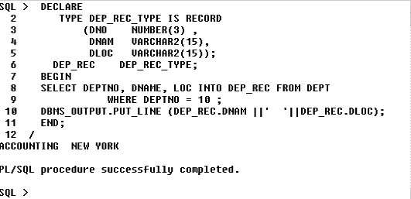

Q4.A)Consider relational schema

**Employee** **(** Eno, Ename, Deptno, Salary **)**

**Department** **(** Deptno, Dname **)**

Write SQL Queries for following questions

* 1. List of employee names of 'Computer ' department.
  2. Find the Employee whose Salary above 50000 of each department.
  3. Find Department name of employee name 'Amit'.

|  |
| --- |
| B) **Differentiate between SQL and PL/SQL.** |

1. SQL is a **Structured Query Language** used to issue a single query or execute a single insert/update/delete.
2. PL-SQL is a  **programming language SQL**, used to write full programs using variables, loops,operators etc. to carry out multiple selects/inserts/updates/deletes.
3. SQL may be considered as the source of data for our reports, web pages and screens.
4. PL/SQL can be considered as the application language similar to  Java or PHP. It might be the language used to build, format and display those reports, web pages and screens.
5. SQL is a data oriented language used to select and manipulate sets of data.  
   PL/SQL is a procedural language used to create applications.
6. SQL may be considered as the source of data for our reports, web pages and screens.
7. PL/SQL can be considered as the application language similar to  Java or PHP. It might be the language used to build, format and display those reports, web pages and screens.
8. SQL is a data oriented language used to select and manipulate sets of data.  
   PL/SQL is a procedural language used to create applications.
9. SQL is a data oriented language for selecting and manipulating sets of data. PL/SQL is a procedural language to create applications.
10. PL/SQL can be the application language just like Java or PHP can. PL/SQL might be the language we use to build, format and display those screens, web pages and reports.SQL may be the source of data for our screens, web pages and reports.
11. SQL is executed one statement at a time. PL/SQL is executed as a block of code.
12. SQL tells the database what to do (declarative), not how to do it. In contrast, PL/SQL tell the database how to do things (procedural).
13. SQL is used to code queries, DML and DDL statements. PL/SQL is used to code program blocks, triggers, functions, procedures and packages.
14. We can embed SQL in a PL/SQL program, but we cannot embed PL/SQL within a SQL statement.

C**) What is JOIN? Explain Different types of JOIN**

There are four basic types of SQL joins: inner, left, right, and full. The easiest and most intuitive way to explain the difference between these four types is by using a Venn diagram, which shows all possible logical relations between data sets.

Again, it's important to stress that before you can begin using any join type, you'll need to extract the data and load it into an RDBMS like Amazon Redshift, where you can query tables from multiple sources. You build that process manually, or you can use an ETL service like [Stitch](https://www.stitchdata.com/features/?utm_source=sqljoin&utm_medium=microsite&utm_campaign=sqljoin-microsite), which automates that process for you.

Let’s say we have two sets of data in our relational database: table A and table B, with some sort of relation specified by primary and foreign keys. The result of joining these tables together can be visually represented by the following diagram:

The extent of the overlap, if any, is determined by how many records in Table A match the records in Table B. Depending on what subset of data we would like to select from the two tables, the four join types can be visualized by highlighting the corresponding sections of the Venn diagram:

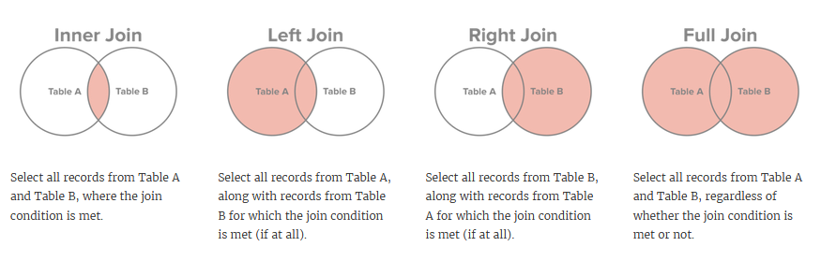

* **Cross JOIN or Cartesian Product**
* This type of JOIN returns the cartesian product of rows of from the tables in Join. It will return a table which consists of records which combines each row from the first table with each row of the second table.
* Cross JOIN Syntax is,

SELECT column-name-list

from *table-name1*

**CROSS JOIN** *table-name2*;